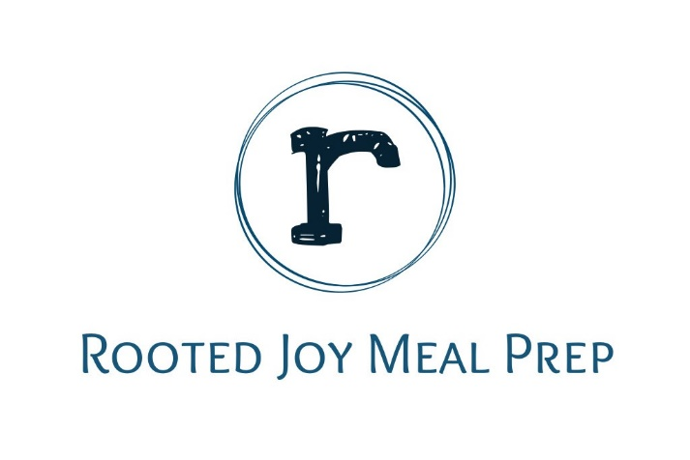
Pick up location
2968 HWY 2779
Hardinsburg, KY 40143
(270)668-9998

Pick up Friday 4-6 pm CST & Saturday 12pm-3 pm CST
Deliveries within Hardinsburg City Limits, Saturday mornings

Clean prep $7.50
Seasoned prep $8.50
Bowls $10.00
(Tax not included)

Pickup January 8th and 9th
Clean Prep- Paprika shredded chicken thigh, jasmine rice and steamed green beans.
400 Calories, 42 Carbs, 13 Fat, 25 Protein.

Seasoned Prep- Seasoned beef and broccoli over roasted potatoes.
352 Calories, 26 Carbs, 15 Fat, 27 Protein.

Bowl- Big Ol’ Burger Bowl, with ground beef, sweet potato fries, pickles, salad and dressing.
430 Calories, 18 Carbs, 24 Fat, 25 Protein.

Soup of the week $6.00
Vegetable beef soup
Calories 219, 14 Carbs, 7 Fat, 22 Protein

Pickup January 15th and 16th
Clean Prep-Shredded Lemon chicken breast with brown rice and steamed green beans.
300 Calories, Carbs 38, Fat 4, Protein 29.
Seasoned Prep-Meatball marinara with roasted spaghetti squash .
332 Calories, 20 Carbs, 17 Fat, 25 Protein.

Bowl-Sushi bowl with cooked shrimp, jasmine rice, shredded carrots, cucumbers and yum yum sauce.
440 Calories, 46 Carbs, 13 Fat, 31 Protein.

Soup of the week $6.00
Chicken Ramen broth bowl
200 Calories, 19.6 carbs, 2.2 fat, 27.9 protein

Pickup January 22nd and 23rd
Clean Prep-Seasoned beef with jasmine rice and peas.
456 Calories, 67 Carbs, 8 Fat, 29 Protein.

Seasoned Prep-Philly Cheesesteak Stuffed peppers with a side of roasted cauliflower.
344 Calories, 13 Carbs, 24 Fat, 22 Protein.

Bowl-Chicken fajitas with a side of tex-mex caulirice drizzled with cilantro cream sauce.
380 Calories, 23 Carbs, 21 Fat, 28 Protein.

Soup of the Week $6.00
Italian Chicken Vegetable
Calories 247, 11 Carbs, 11 Fat, 17 Protein

Pickup January 29th and 30th
Clean Prep-Seasoned pork loin with caulirice.
330 Calories, 11 Carbs, 11 Fat, 39 Protein.

Seasoned Prep-Philly Steak Stuffed peppers with a side of roasted cauliflower.
344 Calories, 13 Carbs, 24 Fat, 22 Protein.

Bowl-Salmon patty bowl with crisp kale, roasted chickpeas, carrots, and paprika vinaigrette.
400 Calories, 30 Carbs, 19 Fat, 28 Protein.

Pickup February 5th and 6th
Clean Prep- Shredded chicken breasts with jasmine rice and peas.
330 calories, 45 Carbs, 2 Fat, 30 Protein.

Seasoned Prep-Roasted chicken thighs with green beans, peppers, and butternut squash.
344 Calories, 13 Carbs, 24 Fat, 22 Protein.

Bowl-Beef barbacoa with tex mex caulirice, fresh salsa, and cilantro sauce.
433 calories, 18 Carbs, 2 Fat, 32 Protein.

Pickup February 12th and 13th
Clean Prep- Lemon chicken caulirice.
222 calories, 11 Carbs, 4 Fat, 34 Protein.

Seasoned Prep-Cauliflower lasagna.
344 Calories, 13 Carbs, 24 Fat, 22 Protein.

Bowl-Steak and Ramen bowl with broccoli and mushrooms.
415 Calories, 24 Carbs, 22 Fat, 29 Protein.

Pickup February 19th and 20th
Clean Prep- Seasoned ground turkey with brown rice and brussel sprouts.
370 calories, 40 Carbs, 11 Fat, 28 Protein.

Seasoned Prep-Maple garlic pork loin with roasted broccoli and quinoa.
390 Calories, 35 Carbs, 14 Fat, 27 Protein.

Bowl-Sloppy Joe bowl with roasted spaghetti squash and broccoli.
395 calories, 22 Carbs, 19 Fat, 23 Protein.

Breakfast
Vegan Overnight oats - $8.00 (2 servings)
PB&Strawberry
Per serving
381 Calories, Carbs 40, Fat 21, Protein 13.
Brownie Batter Oats
Per serving
402 Calories, 65 carbs, 12 Fat, Protein 8.

Oatmeal bake- $8.50
Baked oatmeal topped with peanut butter drizzle and a side of homemade chicken sausage.
495 Calories, 39 Carbs, 25 Fat, 28 Protein

Snacks
Paleo Muffins  Almond butter chocolate chip muffins  Calories 237, Carbs 18, Fat 20, Protein 7  2 for $4.00  4 for $7.50 | Keto  Cheesecake Fluff  Calories 220, Carbs 5, Fat 22, Protein 1.  Half order (1 serving) $3.50  Full order(2 servings) $6.00

All nutritional information is available under each item.
There are 3 categories for meals listed and each have different prices. See first page.
Pickups are Fridays 4-6 pm CST and Saturdays 12-3 pm CST.
ALL INVOICES MUST BE PAID WITHIN 48 HOURS!!

Thank you for your business!

